Welcome to Riga,
to the final conference
of the Erasmus+ project MODEST!
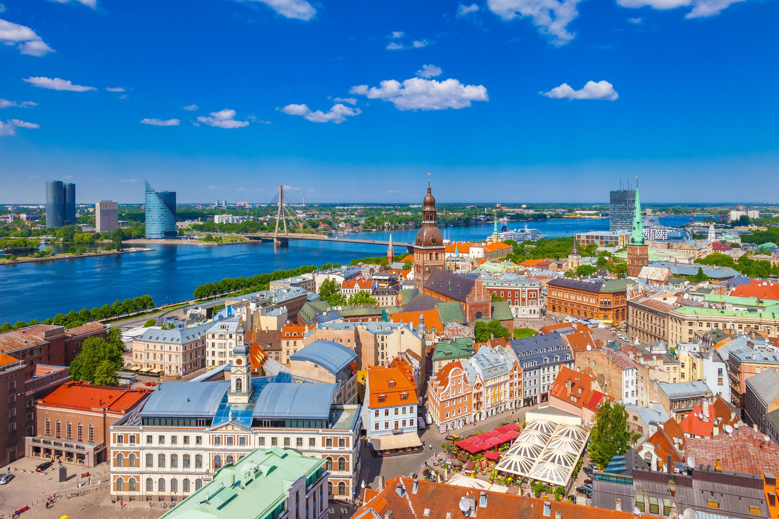
The MODEST (Modernization of Doctoral Education in Science and Improvement of Teaching Methodologies) project aims to improve the quality of doctoral studies in engineering by modernizing the curriculum, optimizing doctoral studies, facilitating the supervision of scientific research and increasing academic mobility.
MODEST is a three-year project with the wider aim of enhancing cooperation between higher education institutions in partner countries in the field of doctoral studies in the European Higher Education Area (EHEA) and the European Research Area (ERA).

MODEST Project Final Hybrid Meeting
Riga, Latvia, on 3rd of November, 2022
Zoom link:
https://lu-lv.zoom.us/j/95258404111?pwd=Q2Y2NTlRMmVCS3hISjI0aWRRc0NlQT09

AGENDA THURSDAY, 3 November
09:00 – 09:20 | Registration
09:20 – 09:30 | Welcome |  | Vice-Rector for Natural Sciences, Technology and Medicine of University of Latvia prof. V.Seglins
09:30 – 09:50 | Quo vadis? Institutional practices to build the universities profile and enhance policy making processes at doctoral training centers (MODEST project experience) |  | Inga Skendere, Director of the Study development and governance improvement program of the University of Latvia
09:50 – 10:10 | Role of soft skills in doctoral studies and research (presentation will be online) |  | Dr. Alexander Mahura, Institute for Atmospheric and Earth System Research/ Physics Faculty of Science; Dr, Katja Lauri, Research Director, Institute for Atmospheric and Earth System Research (INAR) Teachers' Academy University of Helsinki
10:10 – 10:30 | New opening for doctoral education – Doctoral training centers in MODEST project |  | Yerevan State University, National Polytechnic University of Armenia, Armenian State Pedagogical University named after Kh. Abovyan
10:30 – 10:50 | Virtual networking platform |  | Nazmul Huda, Brunel University London
10:50 – 11:10 | Coffee break
11:10 – 11:50 | New horizons for MODEST possible follow up |  | Dr.hab. Marek Frankowicz, Dr. Alicja Rafalska – Lasocha, Faculty of Chemistry, Jagiellonian University
11:50 – 12:30 | Discussion – PhD for the 21st Century |  | Dr.hab. Marek Frankowicz, Dr. Alicja Rafalska – Lasocha, Faculty of Chemistry, Jagiellonian University
12:30 – 13:30 | Lunch
13:30 – 15:00 | Doctoral projects and initiatives in Europa – searching for common denominators, striving for synergy |  | Moderator: Dr.hab. Marek Frankowicz  (Representatives of Coimbra group, EUA, DocEnhance, ARMDOCT, FORTHEM, RECAPHE)
15:00 – 15:30 | Coffee break
15:30 – 16:30 | Continuation of Doctoral projects and initiatives in Europa – searching for common denominators, striving for synergy
16:30 – 17:30 | Discussion and conclusions
18:30 | Concert “On the road…” by choir of the University of Latvia “Balta”

